TCNJ School of Engineering Tutoring Program Tutorial for Tutors

Quick Reference Guide:
- Make sure that you have signed into your TCNJ email through Google Apps before.
- If you haven’t done so yet, follow this link to sign up as a tutor.
- Once you’ve been added (1-4 days), you will receive a confirmation email.
- Sign into your TCNJ email through Google Apps.
- Click on “Calendar” in the upper left corner.
- All of the subjects that you have requested should now be listed under “Other calendars”.
- Let’s say you want to show that you are available to tutor at 3pm on Tuesday. Click the box corresponding to 3pm Tuesday. If there are already appointments at this time, click on the white space on the left in the same time slot.
- A speech box will appear. Click “Appointment slots” at the top. Type your name in the “What” text field. Change the “Calendar” drop down menu to the subject that you want. Click “Edit details”.
- Double check that the correct subject’s calendar is selected from the drop down menu (circled in red above)
- Notice that you can change the length of time that you are making yourself available as well as how long you would like each appointment slot to be.
- If you want to make yourself available on a regular basis at this time (e.g. once a week, once a month, every other Tuesday and Friday, etc.) check the “Repeat…” checkbox.
- Enter where you want to meet (Not necessarily where you want to tutor).
- Enter the name of the professor you had for that subject and the grade you received (optional) in the “Description” text field.
- Click “Save”.
- The appointment slot(s) you have just created should be the color corresponding to the subject’s calendar that you specified at the time you specified.
- Repeat steps 7-15 for all subjects that you are qualified to tutor.
- When a student schedules one of your appointments, a dark box with white text appears next to the appointment slot.
- Check your subjects’ calendars when you check your mail (making sure the subject calendars are selected/highlighted on the left) and make a note of the times and dates so you don’t forget!

- You can edit or delete the event by clicking on it and selecting the proper option.
- Scroll down for instructions with pictures.

- Make sure that you have signed into your TCNJ email through Google Apps before.
- Email the School of Engineering tutoring at soetutoring@gmail.com. Put “New Tutor” in the subject line. Include your TCNJ email address if you are sending the email from a different account. List the subjects that you would like to tutor in. The subjects offered are Advanced Math for Engineers I, Advanced Math for Engineers II, Circuits Analysis, Control Systems, Digital Circuits and Microprocessors, Dynamics, Statics, Strength of Materials, and Thermodynamics I.
- Once you’ve been added (1-4 days), you will receive a confirmation email.
- Sign into your TCNJ email through Google Apps.
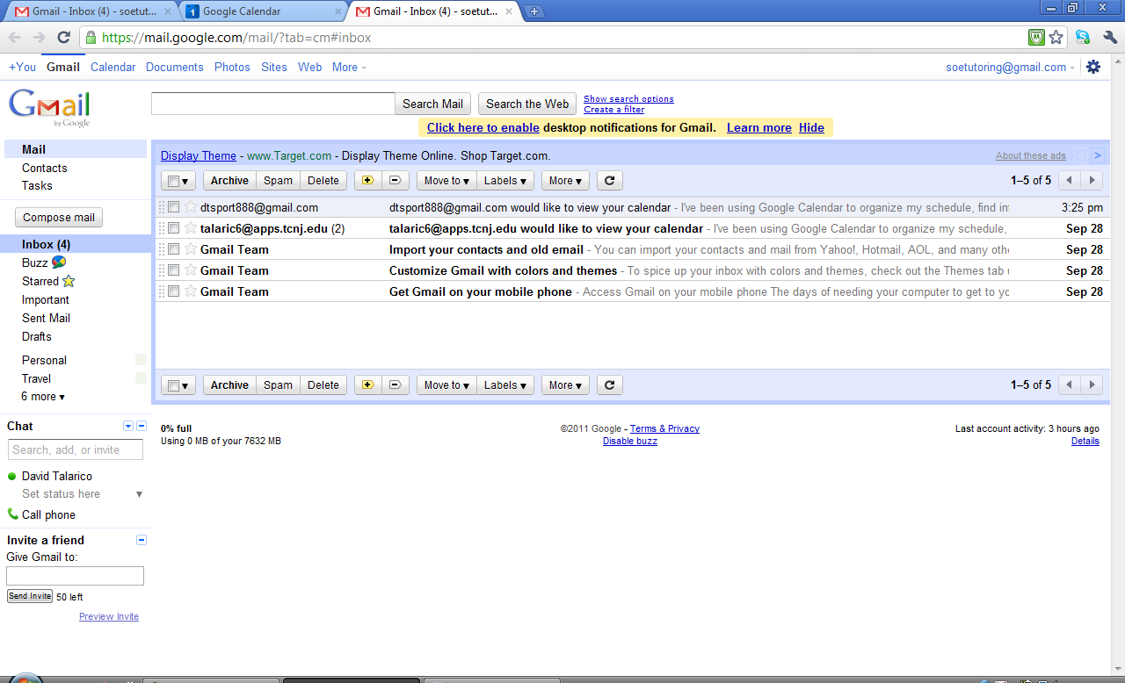
- Click on “Calendar” in the upper left corner.

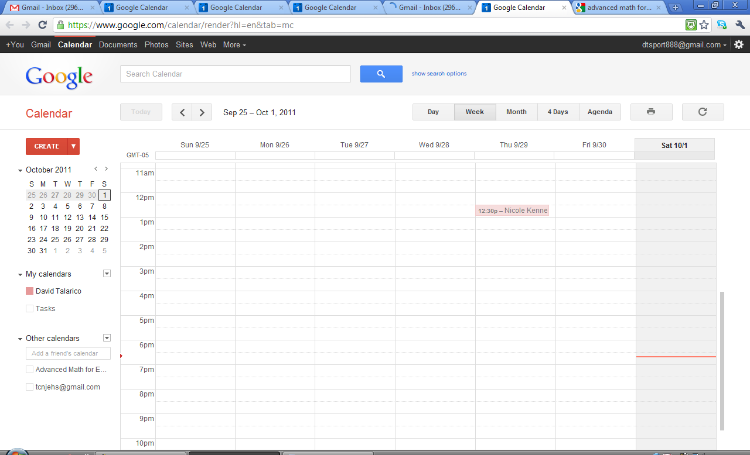
- All of the subjects that you have requested should now be listed under “Other calendars”.
- Let’s say you want to show that you are available to tutor at 3pm on Tuesday. Click the box corresponding to 3pm Tuesday. If there are already appointments at this time, click on the white space on the left in the same time slot.
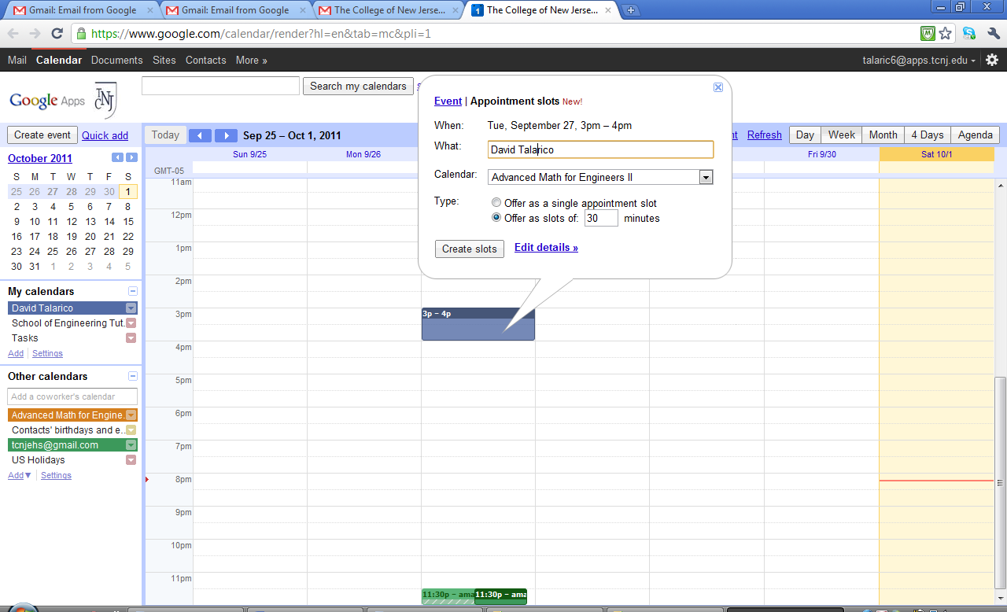
- A speech box will appear. Click “Appointment slots” at the top. Type your name in the “What” text field. Change the “Calendar” drop down menu to the subject that you want. Click “Edit details”.
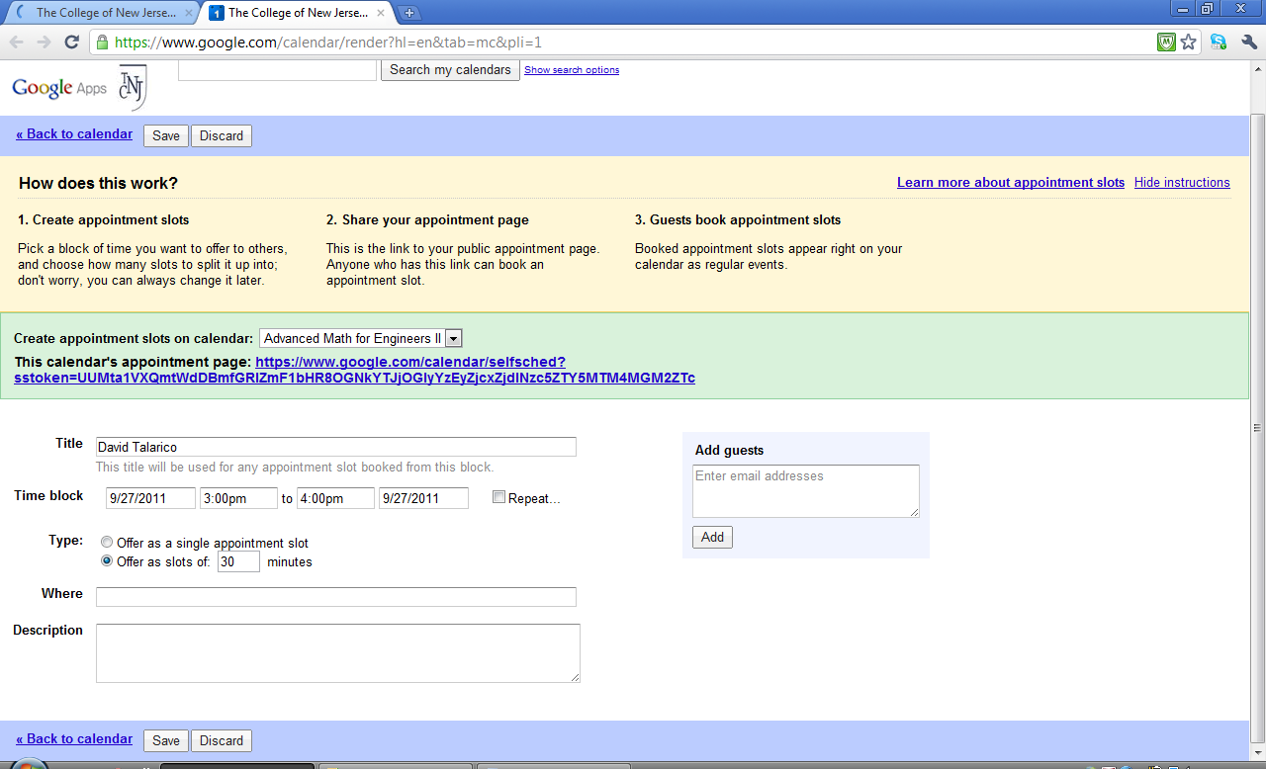
- Double check that the correct subject’s calendar is selected from the drop down menu (circled in red above)
- Notice that you can change the length of time that you are making yourself available as well as how long you would like each appointment slot to be.
- If you want to make yourself available on a regular basis at this time (e.g. once a week, once a month, every other Tuesday and Friday, etc.) check the “Repeat…” checkbox.
- Enter where you want to meet (Not necessarily where you want to tutor).
- Enter the name of the professor you had for that subject and the grade you received (optional) in the “Description” text field.
- Click “Save”.

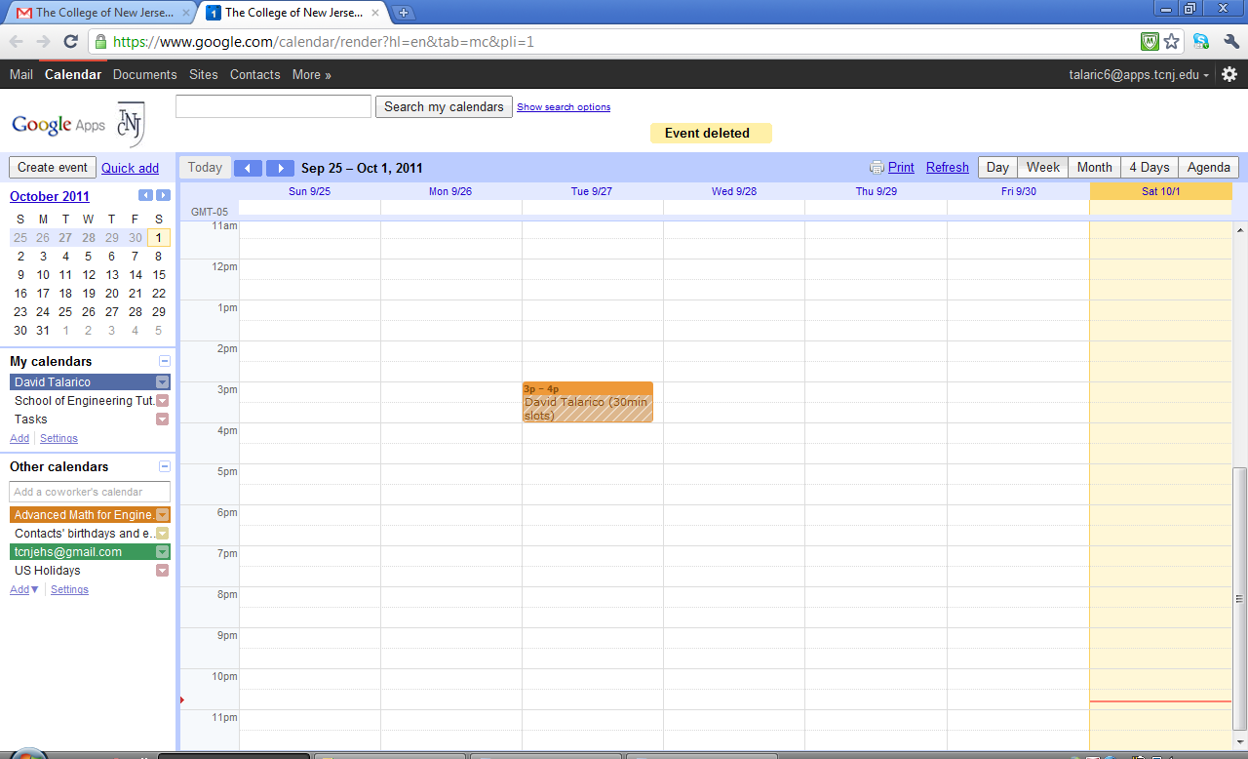
- The appointment slot(s) you have just created should be the color corresponding to the subject’s calendar that you specified at the time you specified.
- Repeat steps 7-15 for all subjects that you are qualified to tutor.

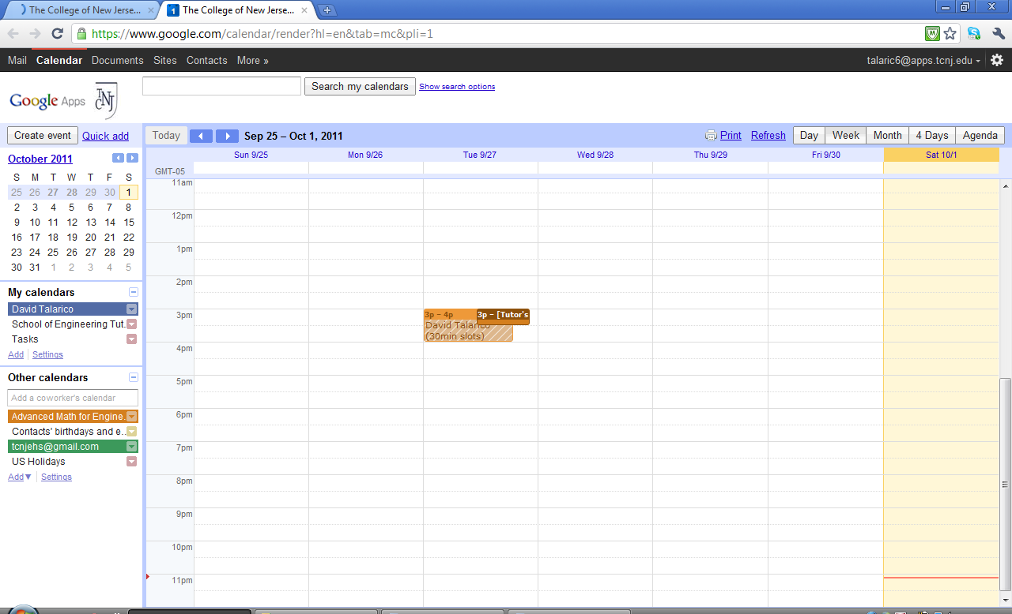
- When a student schedules one of your appointments, a dark box with white text appears next to the appointment slot.
- Check your subjects’ calendars when you check your mail (making sure the subject calendars are selected/highlighted on the left) and make a note of the times and dates so you don’t forget!
(Note: You can edit or delete the event by clicking on it and selecting the proper option.)

