TCNJ School of Engineering Tutoring Program Tutorial for Students

Quick Reference Guide:
- Sign into your email with Google Apps login
- Click “Calendar” in the upper left corner.
- In the “Add a coworker’s calendar” field (just below “Other calendars”), copy and paste the calendar’s email address corresponding to the course you need tutoring in (listed below). Press enter. Subject should appear under “Other calendars”.
Course Title | Calendar’s Email Address
Advanced Math for Engineers I | rsu0bnmv9q8usr0mldvvq9nsuo@group.calendar.google.com
Advanced Math for Engineers II | 71j00o0ab3gmoiu4v21pscgqr0@group.calendar.google.com
Circuits Analysis | ij0laauoc75jbojrcb120sm9uo@group.calendar.google.com
Control Systems | o71n33qpe424hjtto2l9kv5pog@group.calendar.google.com
Digital Circuits and Microprocessors | 191n6pfov1a1jse5ggr9gh19q8@group.calendar.google.com
Dynamics | gthu70r4jqk1cvv065tf9tfpck@group.calendar.google.com
Statics | cchgpmhj4d1sidbghtco6t3iec@group.calendar.google.com
Strength of Materials | 9kokhu0sd0m5l5oa428hp7tmj4@group.calendar.google.com
Thermodynamics I | u5re0qide475vfedd1h5sme7kc@group.calendar.google.com
- Make sure only the calendar you wish to be tutored from is selected (colored) under “Other calendars”.
- Click on an appointment slot that is good for you.
- Select “Book an appointment slot”
- A button will appear for each appointment slot. Click the one you want.
- A window will pop up. Type where you want to meet (if not specified by tutor), what professor you have, and what topics you need help with. Click “Save”.
- Select “View/edit in Google Calendar”.
- Click the back arrow
- Deselect the subject calendar. Select the calendar titled your name. The calendar should display the appointment you just made. Congrats, you just made your first appointment through SoE Tutoring!

- You can cancel at any time by first making sure that the calendar with your name as the title is selected. Next, click the event you want to cancel and select “Cancel appointment”. Then, click “Cancel/Delete and notify guests”.

- If the tutor and student forget to specify a location, meet at the tables in front of the Kineticart.

- Scroll Down for more detailed instructions and pictures.
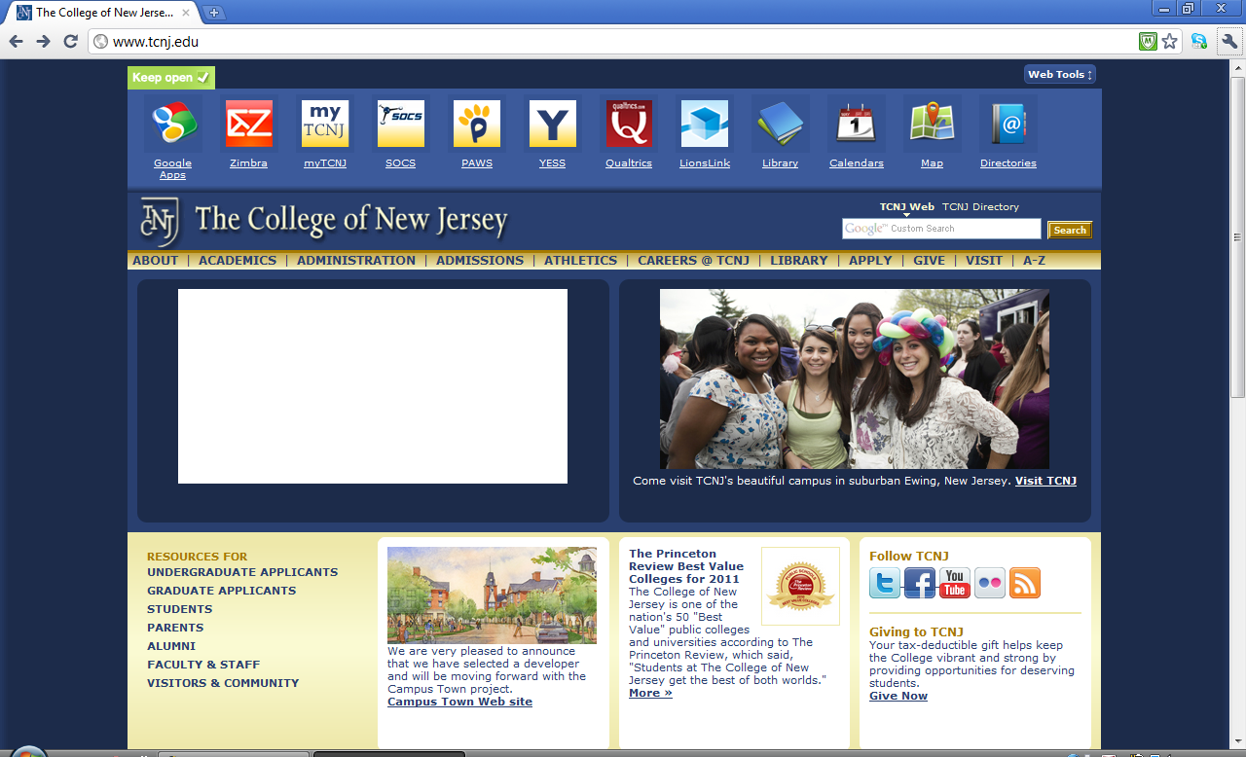
- Sign into your email with Google Apps login
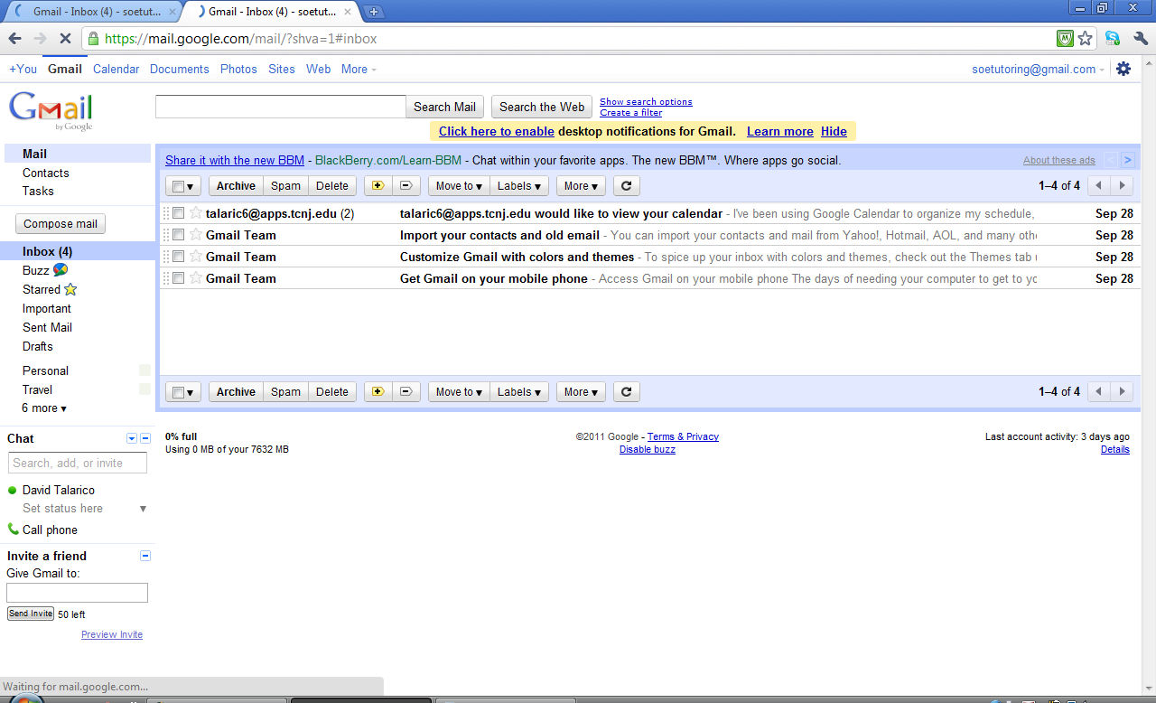
- Click “Calendar” in the upper left corner.
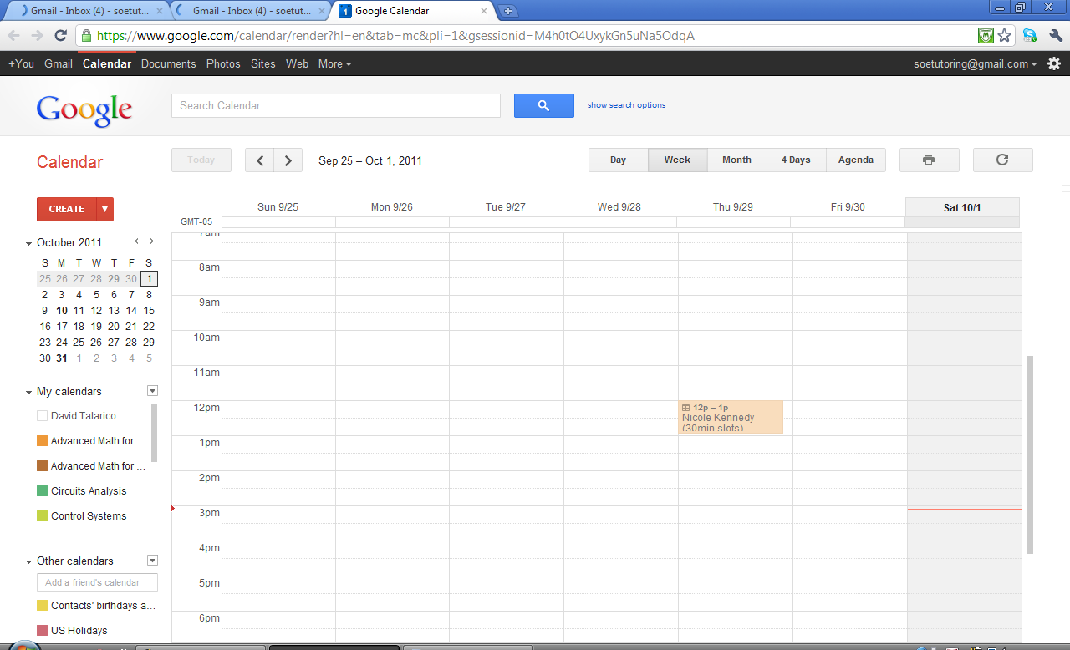
- In the “Add a coworker’s calendar” field, copy and paste the calendar’s email address corresponding to the course you need tutoring in (listed below). Press enter. Subject should appear under “Other calendars”.
Course Title | Calendar’s Email Address
Advanced Math for Engineers I | rsu0bnmv9q8usr0mldvvq9nsuo@group.calendar.google.com
Advanced Math for Engineers II | 71j00o0ab3gmoiu4v21pscgqr0@group.calendar.google.com
Circuits Analysis | ij0laauoc75jbojrcb120sm9uo@group.calendar.google.com
Control Systems | o71n33qpe424hjtto2l9kv5pog@group.calendar.google.com
Digital Circuits and Microprocessors | 191n6pfov1a1jse5ggr9gh19q8@group.calendar.google.com
Dynamics | gthu70r4jqk1cvv065tf9tfpck@group.calendar.google.com
Statics | cchgpmhj4d1sidbghtco6t3iec@group.calendar.google.com
Strength of Materials | 9kokhu0sd0m5l5oa428hp7tmj4@group.calendar.google.com
Thermodynamics I | u5re0qide475vfedd1h5sme7kc@group.calendar.google.com

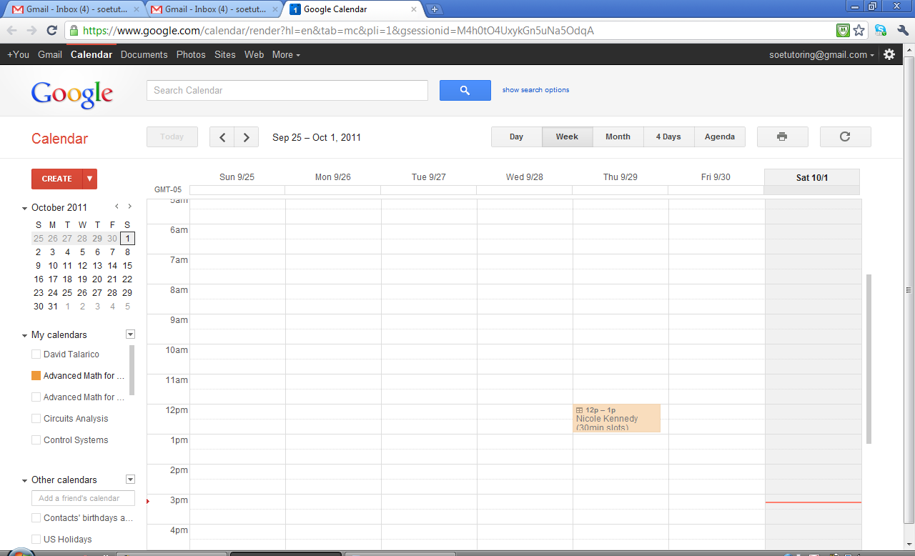
- Let’s say you need to be tutored in Advanced Math for Engineers I. If you have multiple calendars under “My calendars” and/or “Other calendars”, make sure that all of the other calendars are not selected (colored) by clicking on them. Don’t forget to scroll down.
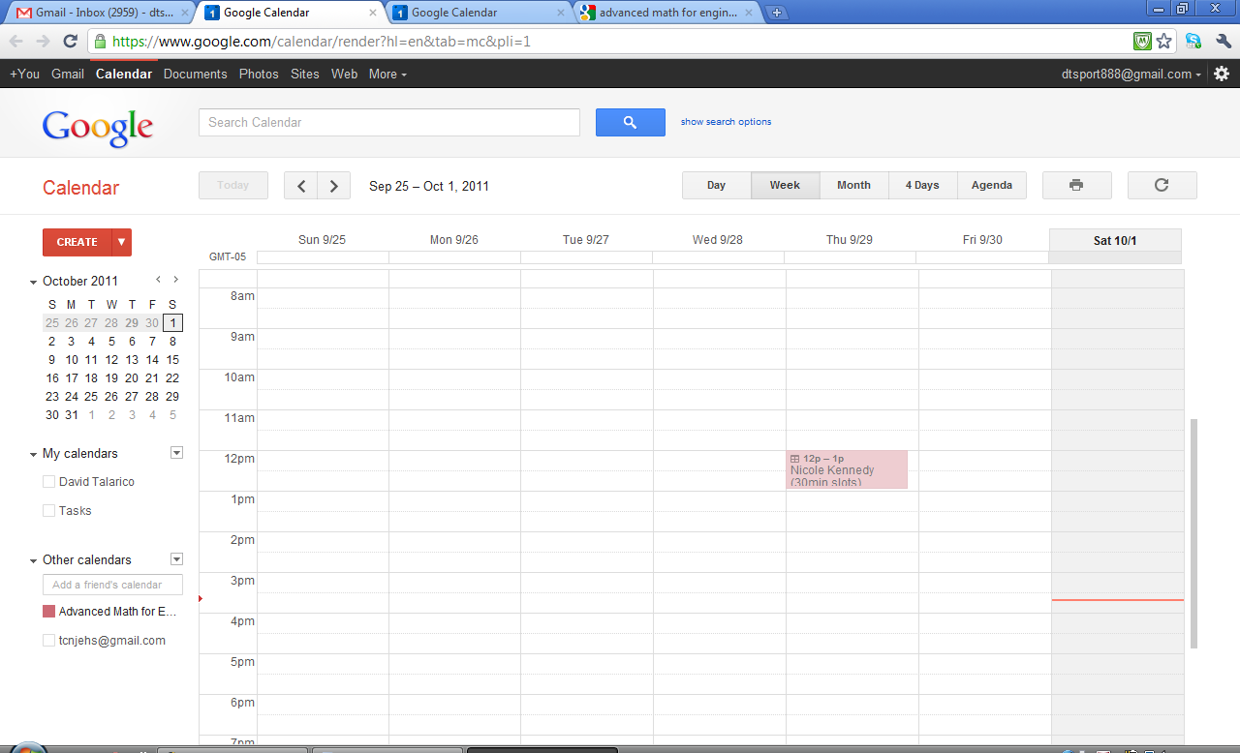
- When the square next to the calendar that you need tutoring in is the only one colored in, the calendar will display the names of the tutors qualified for that subject and their appointment slots. If there are many slots available at the same time, click “Day” right above the calendar. Here, Nicole is offering two 30 minute slots from 12pm-1pm on 9/29/11. Click the appointment.
- Select “Book an appointment slot”
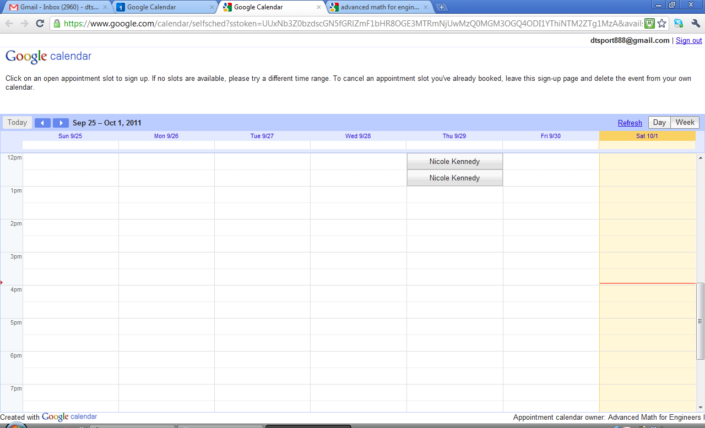
- A button will appear for each appointment slot. Click the one you want. 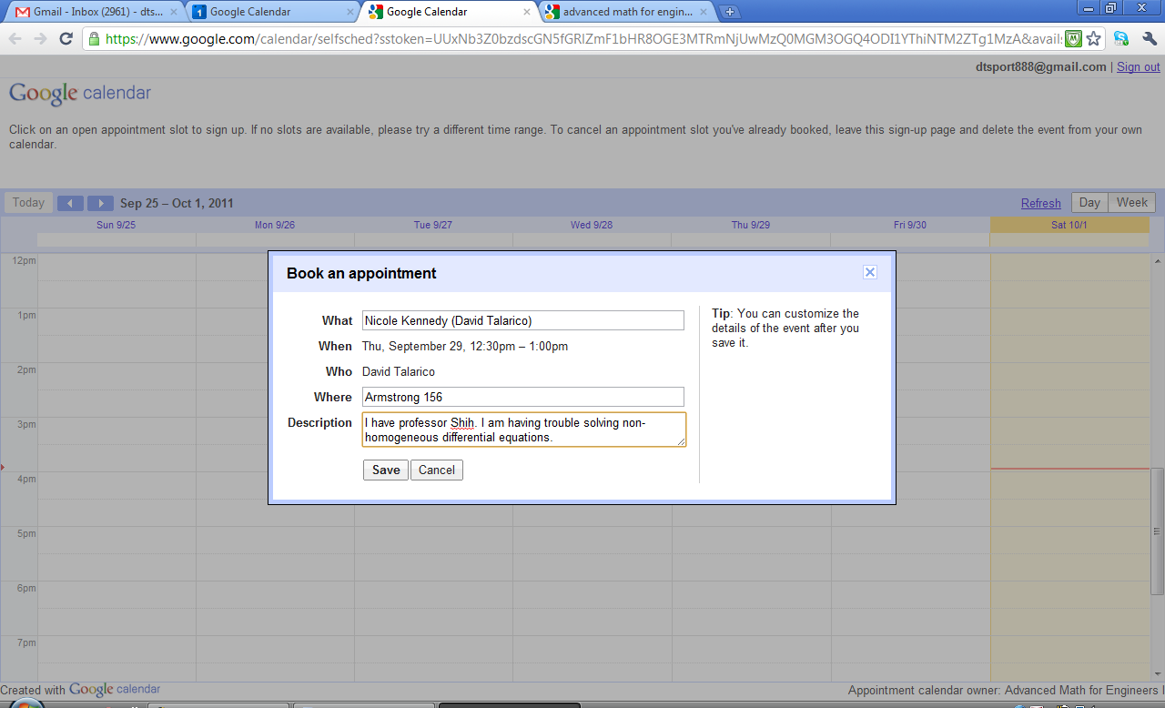
- A window will pop up. Type where you want to meet (if not specified by tutor), what professor you have, and what topics you need help with. Click “Save”.
- Select “View/edit in Google Calendar”.
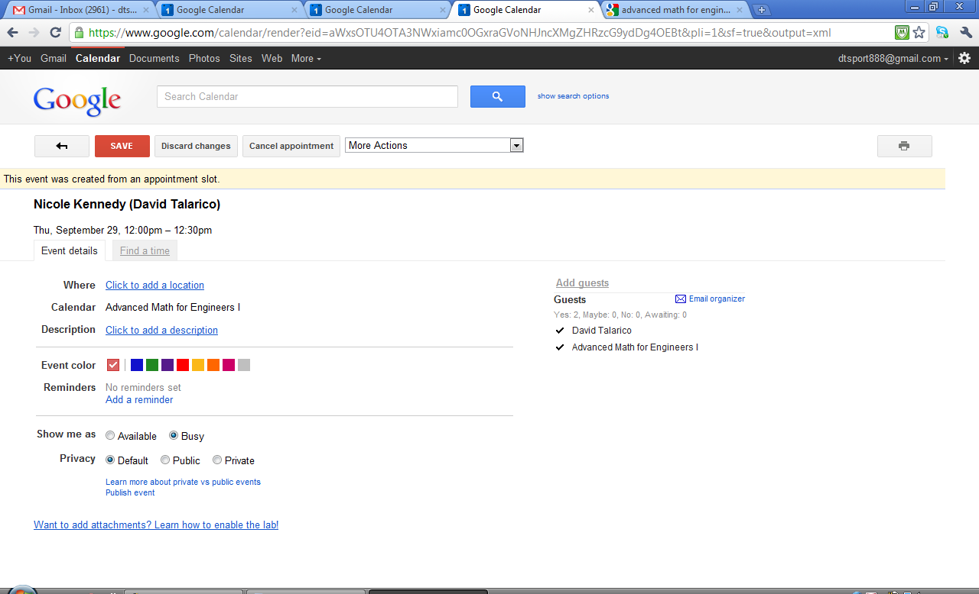
- Click the back arrow
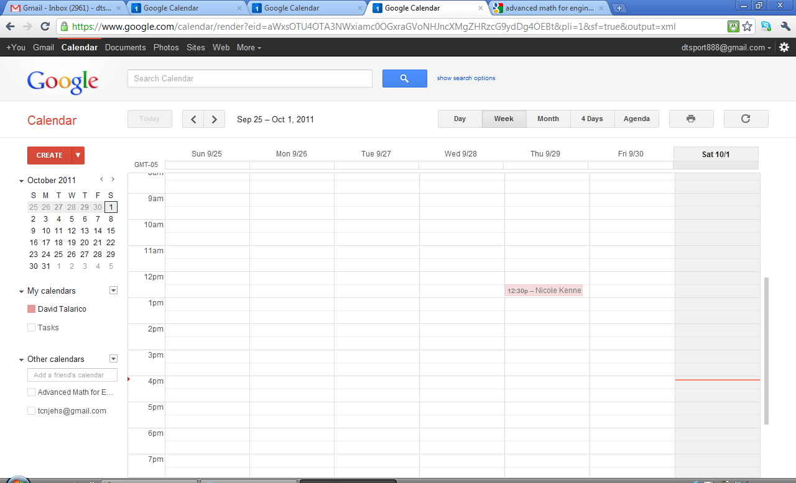
- Deselect the subject calendar. Select the calendar titled your name. The calendar should display the appointment you just made. Congrats, you just made your first appointment through SoE Tutoring!
(Note: You can cancel at any time by first making sure that the calendar with your name as the title is selected. Next, click the event you want to cancel and select “Cancel appointment”. Then, click “Cancel/Delete and notify guests”. )
(Note: If the tutor and the student both forget to specify a location, meet at the tables in front of the Kineticart.)

